Announcing the 1st Annual Pittsburgh Sakura Festival

Please join us!!

Place: Near the Boat House in North Park
Date: Sunday, April 29, 2012, from 3:00 PM to 5:30 PM
Event: Planting 3 ceremonial young cherry trees and 3 others,
Taiko, Music Performances, Kite flying, Folk dance, Tea ceremony, Raffle, and more!
Organizer: Pittsburgh Sakura Project www.pghsakuraproject.org

To register as a volunteer, please send an email to Yoko Motoyama, at yokohm@gmail.com
☆Pittsburgh Sakura Project assumes no legal or financial liability for accidents or injuries during and after this event.

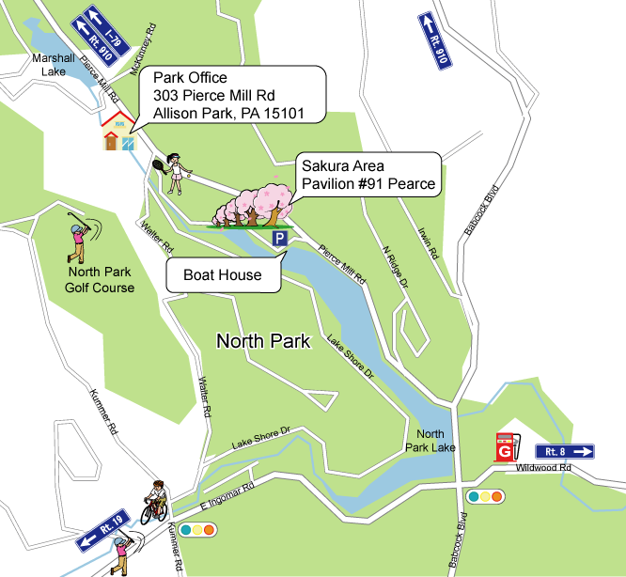

From our Inaugural Planting Day, on April 25, 2009, through our most recent planting event, on November 12, 2011, volunteers have planted a total of 201 trees at our site in North Park. Over that time, the PSP purchased 94 young ornamental cherry trees, and Allegheny County’s Tree Vitalize program provided 22 additional cherries and 85 other native trees. Our next major planting day will be in November of 2012. This spring we will hold our first Cherry Blossom Festival, on Sunday, April 29, in honor of the centennial of the original gift of cherry trees from Japan to the US in 1912. We hope you can join us!
_________________________________________clip here_______________________________________________
To make a tax deductible donation to the Pittsburgh Sakura Project, please fill in the form below, and mail, with a check payable to “Pittsburgh Sakura Project” to:
Pittsburgh Sakura Project c/o Fumio Yasuzawa, 2032 Murray Ave, Pittsburgh, PA 15217

I am making a tax deductible donation to the Pittsburgh Sakura Project.
$25 _____ $50 _____ $100 _____ $200 _____ $300 _____ Other _____
Name:＿＿_______________ Email: ＿＿____________ Mailing address:____________________________

